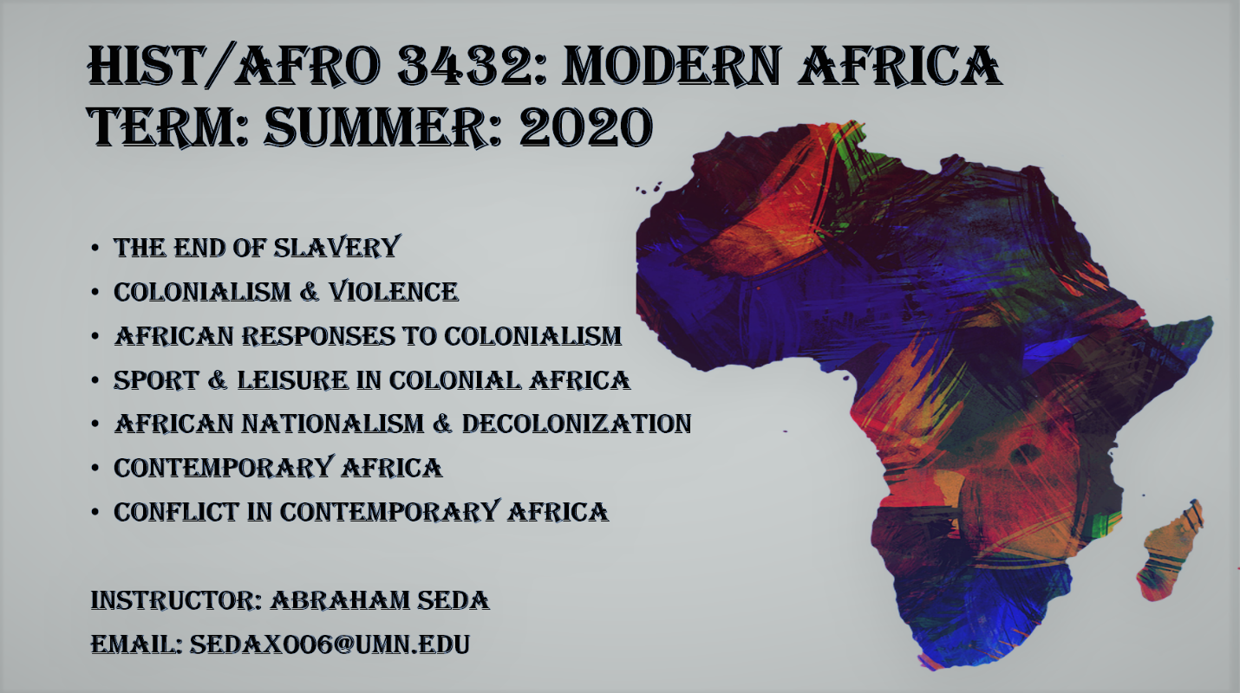

MODERN AFRICA IN A CHANGING WORLD: THE HISTORY OF AFRICA SINCE 1800

JUNE 8 – JULY 2, 2020.

Instructor: Abraham Seda
Email: sedax006@umn.edu
Lectures: M, T, W, TH 1-3:30pm

There are no fixed office hours. Students are therefore encouraged to make appointments via zoom between Monday and Thursday

Course overview
The class investigates the history of Africa through themes such colonization, slavery, leisure and sport. Students are encouraged to reflect on what Africa means to them, and how racism has played a part in shaping the history and perceptions of the continent. The class utilizes a novel, a textbook, peer reviewed articles to inspire conversations about the aforementioned themes and more. Although learning the materials and the history of Africa are central aspects of the class, the course also wrestles with processes of knowledge production, and the extents to which ‘knowledge’ produced about Africa has perpetuated stereotypes that have endured since colonial times to the present. My role as the instructor is to teach and facilitate engaging conversations and making sure that each student has an opportunity to share their views.

Important note on registration
For information on how to register if you are not a University see https://onestop.umn.edu/academics/take-class-non-degreeguest-student, You may register for credit, or as an auditor.

Format
Both lecture and discussion will be part of this class. Lively questions and comment are encouraged during class time. We will also view relevant documentaries, films and/or short clips. Although this course presents a thematic approach to the history of Africa, it does also follow a chronological narrative to give a sense of how certain processes, events and ideas unfolded over time, shaping present-day narratives and representations of the continent. Lectures will be delivered ONLINE through zoom.
Required texts
The following required texts are available at the University of Minnesota Bookstore
- Kevin Shillington (2018, 4th edition). History of Africa. St. Martin’s Press.
- Tsitsi Dangarembga, Nervous Conditions, Seal Press, 1988.

Evaluation
Participation & Canvas posts: 20%
Midterm paper: 25%, Due date: June 22, 2020
Test: 20%, Date: June 29, 2020
Final paper: 35%, Due date: July 5, 2020
IF YOU CANNOT TURN IN AN ASSIGNMENT/MID-TERM ON TIME, you may—in writing—let me know that this is the case, the reason for the delay, and propose an alternative date to hand in the assignment. You must adhere to the new date you set yourself. If you do not, you will receive a failing grade for that assignment.
Citation style: Please note that in history we use the Chicago/Turabian Style to reference sources and documents. For the book responses, you may use in-text author-date-page citation together with an alphabetized Reference List/Bibliography for all works cited in parenthetical references. For all other written work please use numbered footnotes and a bibliography. A guide can be found on the UMN Library Website Citation Guides and Style Manuals: http://www.lib.umn.edu/howto/citationguides. All written work must be typed and double spaced.
Scholastic dishonesty: You are expected to do your own academic work and cite sources as necessary. Failing to do so is scholastic dishonesty. Scholastic dishonesty means plagiarizing; cheating on assignments or examinations; engaging in unauthorized collaboration on academic work; taking, acquiring, or using test materials without faculty permission; submitting false or incomplete records of academic achievement; acting alone or in cooperation with another to falsify records or to obtain dishonestly grades, honours, awards, or professional endorsement; altering, forging, or misusing a University academic record; or fabricating or falsifying data, research procedures, or data analysis. (Student Conduct Code: http://regents.umn.edu/sites/regents.umn.edu/files/policies/Student_Conduct_Code.pdf) If it is determined that a student has cheated, the student may be given an "F" or an "N" for the course, and may face additional sanctions from the University. For additional information, please see: http://policy.umn.edu/education/instructorresp.
The Office for Community Standards has compiled a useful list of Frequently Asked Questions pertaining to scholastic dishonesty: https://communitystandards.umn.edu/avoid-violations/avoiding-scholastic-.... If you have additional questions, please clarify with your instructor for the course. As the instructor, I can respond to your specific questions regarding what would constitute scholastic dishonesty in the context of this particular class-e.g., whether collaboration on assignments is permitted, requirements and methods for citing sources, if electronic aids are permitted or prohibited during an exam.

Writing Support: Student Writing Support at the Centre for Writing provides free writing instruction for all University of Minnesota students, at all stages of the writing process. In face-to-face and online collaborative consultations, they can help you develop productive writing habits and revision strategies, particularly for your final paper/project. Please visit http://writing.umn.edu/sws/
Student conduct: The University seeks an environment that promotes academic achievement and integrity, that is protective of free inquiry, and that serves the educational mission of the University. Similarly, the University seeks a community that is free from violence, threats, and intimidation; that is respectful of the rights, opportunities, and welfare of students, faculty, staff, and guests of the University; and that does not threaten the physical or mental health or safety of members of the University community.
As a student at the University you are expected to adhere to Board of Regents Policy: Student Conduct Code. To review the Student Conduct Code, please see: https://z.umn.edu/2wxi Note that the conduct code specifically addresses disruptive classroom conduct, which means "engaging in behaviour that substantially or repeatedly interrupts either the instructor's ability to teach or student learning. The classroom extends to any setting where a student is engaged in work toward academic credit or satisfaction of program-based requirements or related activities."

WEEK ONE
06/08 Situating Africa, The Discipline of [African] History & the Writing of African Histories

G.W.F Hegel, Lectures on the Philosophy of World History, Cambridge University Press, 1822-1830 (available on canvas)
Donald R. Wright, “What do you mean there were no tribes in Africa?’: Thoughts on Boundaries – and Related Maters – in Precolonial Africa,” History in Africa 26 (1999): 409-426
Tsitsi Dangarembga, Nervous Conditions, Ayebia Clarke Publishing Limited, 1988, pp vii-12

06/09 Impact of the Trans-Atlantic Slave Trade & the Colonization of Africa
Walter Rodney, How Europe Underdeveloped Africa, (1982) Chapter 4: Europe and the Roots of African Underdevelopment – to 1885, pp. 95-146
Kevin Shillington, History of Africa, Palgrave Macmillan, 2012, pp311-316
Tsitsi Dangarembga, Nervous Conditions, Ayebia Clarke Publishing Limited, 1988, pp 13-57

06/10 Christian Missionaries and Early Explorers in Africa
Kevin Shillington, History of Africa (2012), pp. 296-298 (European Christian missionaries in pre-colonial Africa); pp. 301-310 (Missionaries as agents of imperialism

06/11 Wars of ‘Conquest’, Violence and African Resistance
Kevin Shillington, History of Africa, Palgrave Macmillan, 2012, pp337-340
Tsitsi Dangarembga, Nervous Conditions, Ayebia Clarke Publishing Limited, 1988, pp 58-77

WEEK TWO

06/15 First Colonies: Sierra Leone and Liberia
Kevin Shillington, History of Africa (2012), pp. 243-246 (Sierra Leone and Liberia); pp. 298-300 (African Christians and pre-colonial nationalism)
“A few facts respecting the American Colonization Society,” American Colonization Society, 1830
Discussion of the novel

06/16 Colonialism in South Africa & Zimbabwe, Sexualizing the African Native
Kevin Shillington, History of Africa (2012), pp. 218-224 (Southern Africa before 1650 to Conflict on the Cape/Xhosa frontier); pp. 271-279 (The British at the Cape to Southern Africa in 1870); pp.333-335 (The colonization of Zimbabwe
Yvette Abrahams, The Great Long National Insult: 'Science', Sexuality and the Khoisan in the 18th and Early 19th Century, Agenda (1997), pp. 34-48

06/17 Women in Colonial Society
Ester Boserup, The Economics of Polygamy in Perspectives on Africa: A Reader in Culture, History and Representation, 2nd ed. (2010), pp. 389-398
Josephine Beoku-Betts, Western Perceptions of African Women in the 19th and Early 20th Centuries, in Readings in Gender in Africa (2005), pp. 20-25

06/18 Labor Migrations and the Colonial City
Eric Allina, “Captive to Civilization: Law, Labor Mobility and Violence in Colonial Mozambique” in Darshan Vigneswaran and Joel Quirk, Mobility Makes States: Migration and Power in Africa, University of Pennsylvania Press, 2015, pp. 59-78
Tsitsi Dangarembga, Nervous Conditions, Ayebia Clarke Publishing Limited, 1988, pp 78-121
Midterm due today (Further instructions & prompt will be provided on the 1st day of class)

WEEK THREE

06/22 Leisure & Recreation in Colonial Africa
Mhoze Chikowero, African Music, Power & Being in Colonial Zimbabwe, Indiana University Press, 2015, pp 187-213 (The Many Moods of “Skokiaan” Criminalized Leisure, Underclass Defiance and Self Narration)
M.T Vambe, “Aya Mahobo: Migrant Labour and the Cultural Semiotics of Harare (Mbare) African Township 1930-1970”, African Identities Vol. 5, No. 3, 2007, pp 355-369
Tsitsi Dangarembga, Nervous Conditions, Ayebia Clarke Publishing Limited, 1988, pp 122-150

06/23 Colonial Sports & the Ideal Colonial Subject
Patrick F McDevitt, May the Best Man Win: Sport, Masculinity and Nationalism in Great Britain & the Empire, 1800-1935, Palgrave McMillan, 2008, pp 1-14 (Gender & Imperial Sport)
Kevin Shillington, History of Africa (2012), pp 361- 367 (The Economic Impact of Colonial Rule), pp 367-370, (The Nature & Impact of Colonial Administration)
Movie: Fire in Babylon

06/24 Anti-Colonial Wars and African Liberation?
Kevin Shillington, History of Africa, 2012, pp 374-378, 393-400
Tsitsi Dangarembga, Nervous Conditions, Ayebia Clarke Publishing Limited, 1988, pp 151-178
Class discussion based on the novel

06/25 Contemporary Africa & the World
Kevin Shillington, History of Africa, 2012, pp 436-438
Chipo Dendere, “What’s Next for Zimbabwe’s Opposition Aljezeera News https://www.aljazeera.com/indepth/opinion/zimbabwe-opposition-180808085412159.html
Tsitsi Dangarembga, Nervous Conditions, Ayebia Clarke Publishing Limited, 1988, pp 179-208
Test based on the novel (Instructions & prompt will be provided two weeks before this date)

WEEK FOUR

06/29 Political Conflict and Ethnic Violence in Independent Africa
Kevin Shillington, History of Africa, 2012, pp
Mahmood Mamdani, When Victims Become Killers: Colonialism, Nativism and the Genocide in Rwanda, Princeton University Press, 2001, pp (Thinking about Genocide/Introduction)

06/30 Global Politics and Natural Resources in Africa
Carmody Padraig, Globalization: Recolonization or Renaissance? Lynne Rienner Publishers, 2010, pp. 11-33, (Chinese & US Interests in Africa), with Francis Owusu
Movie: Blood Diamond

07/1 Health & Healing in Africa
David Baranov, The African Transformation of Western Medicine and the Dynamics of Global Cultural Exchange (2008), Chapter 3, pp. 77-123
Kevin Shillington, History of Africa (2012), 479-480
Joseph R. Oppong and Ezekiel Kalipeni, Perceptions and Misperceptions of AIDs in Africa in HIV and AIDS in Africa: Beyond Epidemiology (2004), pp. 47-57

07/2 Thinking Africa & Reflections Curtis Keim, Mistaking Africa: Curiosities and Inventions of the American Mind, Westview Press, 2014, pp. 15-29

As instructor for the class, I reserve the right to adjust the syllabus as I see fit.

